

**MIDDLE EAST TECHNICAL UNIVERSITY**

**DEPARTMENT OF ELECTRICAL & ELECTRONICS ENGINEERING**

**EE 464- Hardware Project – 2023 Spring**

**Final Report**

**Isolated DC-DC Battery Charger**

**Peaky Converters**

Çağlar Umut Özten

Onur Toprak

Table of Contents

Introduction 3

Key Project Requirements: 3

Additional Objectives: 3

Challenges and Opportunities: 3

Topology Selection 4

Flyback Converter: 4

Forward Converter: 5

• Two Switch Forward Converter 5

Analytical Calculations 7

Magnetic Design 7

• Magnetizing and Leakage Inductance Tests 10

Component Selection 12

• MOSFET 12

o GATE DRİVER 13

• DİODE 13

• OPTOCOUPLER 14

Closed Loop Controller 15

Controller Tuning 16

Simulations 16

Loss Calculations 21

Implementation Process 22

Switching to Forward Converter Topology 22

RC Snubber on Diodes 22

Cost Anaylsis 22

Bonuses 22

Conclusion 22

Achievements 23

Appendix-I : TEST DATA 23

References 23

# Introduction

Due to a variety of applications, including portable electronics and renewable energy systems, there is a constant need in modern power electronics for DC-DC converters that are dependable and efficient. The goal of this project is to design and build an isolated DC-DC converter that satisfies tight requirements for power efficiency, output voltage stability, and input voltage range.   
  
 This converter's goal is to convert an input voltage between 20 and 40 volts into a steady 12 volt output with a maximum power output of 60 watts. Additionally, the converter must have outstanding line and load regulation, with variances of no more than 3% across a range of input voltages and load circumstances, and the output voltage ripple should be kept to a maximum of 3%.

## Key Project Requirements:

**Closed-Loop Control:** A closed-loop control system is essential for maintaining precise regulation of the output voltage under changing input and load conditions. This ensures stability and reliability in various operating scenarios.

**Self-Powered Control Circuits:** The project restricts the use of external power supplies for control circuits, emphasizing the need for a self-powered solution that derives its operational energy from the main power source.

**Magnetic Design:** The magnetic design for the isolated DC-DC converter is a critical aspect that directly impacts performance, efficiency, and size of the converter. The key components requiring careful magnetic design include transformers and inductors.

## Additional Objectives:

Beyond meeting the basic specifications, additional project goals may involve enhancing the converter's efficiency, achieving a compact design, and exploring advanced techniques like soft switching to minimize switching losses and improve overall performance.

## Challenges and Opportunities:

Designing an efficient isolated DC-DC converter requires addressing challenges related to component selection, circuit layout, magnetic design (transformers and inductors), and control strategy. Balancing performance with factors like cost, size, and complexity presents opportunities for innovation and optimization throughout the design process.

Throughout this report, procedure of the DC-DC Isolated Converter will be explained. Step by step, examination of the topology selection, magnetic design and controller will be carried. After checking results with simulations, component selection and further consideratioons will be done.

# Topology Selection

## Flyback Converter:

diyagram, metin, teknik çizim, plan içeren bir resim

Açıklama otomatik olarak oluşturuldu

The flyback converter is a type of isolated DC-DC converter that stores energy in the transformer during the ON time of the switching cycle and releases it to the output during the OFF time. Here's a simplified explanation of how it works:

**Operation:** During the ON time of the switching cycle, the primary winding of the transformer is energized, storing energy in the magnetic field of the transformer core.

**Energy Transfer:** When the switch turns OFF, the magnetic field collapses, inducing a voltage in the secondary winding of the transformer. This voltage is rectified and filtered to provide the desired output voltage.

**Isolation:** The flyback converter provides galvanic isolation between the input and output through the transformer, making it suitable for applications requiring isolation such as in power supplies and converters.

**Advantages:** Simple topology, low component count, and capability of stepping up or stepping down the input voltage.

**Disadvantages:** Typically higher output ripple, lower efficiency compared to forward converters especially at higher power levels, and limited to lower power applications due to transformer size and losses.

## Forward Converter:

diyagram, metin, teknik çizim, plan içeren bir resim

Açıklama otomatik olarak oluşturuldu

The forward converter is another type of isolated DC-DC converter that transfers energy from the input to the output through a transformer during each switching cycle. Here's a brief overview of its operation:

**Operation:** The primary winding of the transformer is energized during the ON time of the switching cycle, transferring energy to the secondary winding.

**Energy Transfer:** Energy is transferred from the primary side to the secondary side of the transformer during each switching cycle, providing isolation and stepping up or stepping down the voltage depending on the transformer turns ratio.

**Continuous Energy Transfer:** Unlike the flyback converter, the forward converter operates with continuous energy transfer through the transformer, resulting in generally higher efficiency and lower output ripple.

**Advantages:** Higher efficiency, lower output ripple, and better regulation compared to flyback converters especially at higher power levels.

**Disadvantages:** More complex control circuitry, additional components such as freewheeling diodes and snubber circuits, and limited duty cycle due to transformer reset constraints.

## Two Switch Forward Converter

diyagram, metin, plan, teknik çizim içeren bir resim

Açıklama otomatik olarak oluşturuldu

The Two-Switch Forward Converter utilizes two active switches (typically MOSFETs) in its primary side circuitry, enhancing its performance and efficiency over the conventional single-switch forward converter. This topology is commonly employed in high-power applications where minimizing losses and improving efficiency are paramount.

**Key Components and Operation:**

Transformer: Similar to the single-switch forward converter, the Two-Switch Forward Converter includes a transformer that facilitates the energy transfer from the input to the output. The transformer typically features separate primary and secondary windings for isolation.

Primary Side:

Active Switches (MOSFETs): The primary side of the converter incorporates two active switches (MOSFETs) configured in a half-bridge topology. One switch is responsible for controlling the primary current during the ON state, while the other switch helps to clamp the leakage energy during the OFF state.

Input Capacitor: A capacitor is connected to the input to filter the input voltage and provide a smooth supply to the switches.

Secondary Side:

Diode and Output Capacitor: The secondary side includes a diode for rectifying the transformer's secondary voltage and an output capacitor to filter the rectified voltage, providing a stable output voltage to the load.

In summary, the choice between flyback and forward converter topologies depends on specific application requirements including power level, efficiency targets, output ripple tolerance, and design complexity considerations. Each topology has its advantages and disadvantages, making them suitable for different types of DC-DC conversion applications.

To conclude, **the Two-Switch Forward Converter** offers enhanced performance and efficiency compared to traditional single-switch forward converters, making it a compelling choice for demanding power conversion applications where minimizing losses and optimizing efficiency are key priorities. Advanced control techniques and careful design considerations are essential for realizing the full potential of this topology in practical implementations. We will try to implement and design for Two switch Forward Converter. Not two switch!!

# Analytical Calculations

diyagram, metin, plan, teknik çizim içeren bir resim

Açıklama otomatik olarak oluşturuldu

At the beginning, for the not saturated core and high core losses, duty cycle must be smaller than 0.5. Moreover, due to the non-idealities and some deviations, the most duty cycle value is taken as 0.45. After that, from the equation, 𝑉𝑜𝑢𝑡 = 𝑉𝑖𝑛 ∗ (𝑁2/𝑁1) ∗ 𝐷, required turns ratio at the 20 V input case is 1.33. After that, for simplicity and safety of the operation modes, turns ratio determined as 1.5. Then duty cycle is calculated for 40 V input voltage case. Value is calculated as 0.3. Finally, with the turn ratio is 1.5, required duty cycle at 20 V input voltage case calculated as the 0.4.

In conclusion, turns ratio determined as the 1.5 and duty cycle varies between 0.2 and 0.4.

# Magnetic Design

By following Infenion’s Forward Design Handout[(1)](https://www.mouser.com/pdfdocs/2-10.pdf);

$n_{1}> \frac{V_{i},\max{ * } Dmax * 1/{f_{S}}}{B_{sat} * { A}_{e}}$**(1)**

$$k_{fill}= \frac{Total copper Area}{Window Area} (2)$$

$L_{o}>(1-\frac{ V_{o} * n1}{V_{i} * n_{2}})* \frac{1}{∆i_{Lo}}$ $* V_{o}*\frac{1}{f_{s}} =96 µH$**(3)**

$ƞ =\frac{P_{o}}{P_{i}}$, ( 80%) $I_{pri,mean,on}=$ $\frac{P_{i}}{V_{i }D}$ = **9.375 A** **(4)**

**(5)**

**(6)**

**(7)**

+ **(8)**

metin, yazı tipi, çizgi, diyagram içeren bir resim

Açıklama otomatik olarak oluşturuldu **(9)**

* Consideration of Toroidal Core;

metin, ekran görüntüsü, çizgi, sayı, numara içeren bir resim

Açıklama otomatik olarak oluşturuldu

Figure 1. Table for Toroidal core turns and fill factor Calculations using (1) and (2)

By looking at this table (Figure X), we decided to use 79440A7 core. After implementation of the 6:9 turns ratio on the core by Litz wire, we started to calculate $L_{magnetizing}$ (Magnetizing Inductance) and $L_{leakage}$ (Leakage Inductance). After testing on LCR Meter, we understood that, its $L_{leakage}$ is too high and $L_{magnetizing}$ is too low if we consider current ripple on the MOSFET **(7)**. So that, we decided to use **E-core**.

After consideration of the E-cores in labaratory, we decided to use **0P45530EC cores.**

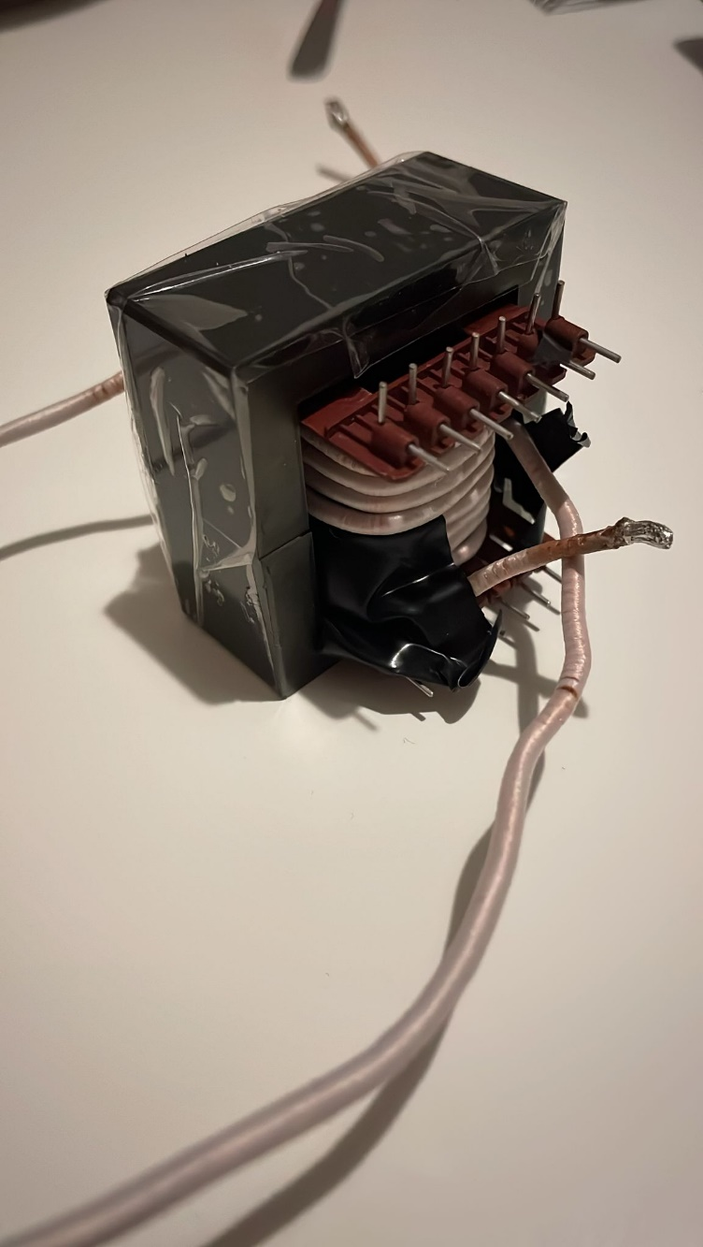

Figure 2. Transformer Design with **0P45530EC and 4:6, Litz wire**

For output inductor, consideration of ensuring CCM at 10% load; $∆i_{Lo}<1 A$

We calculated minimum output inductance as **96 µH**, by using (3).

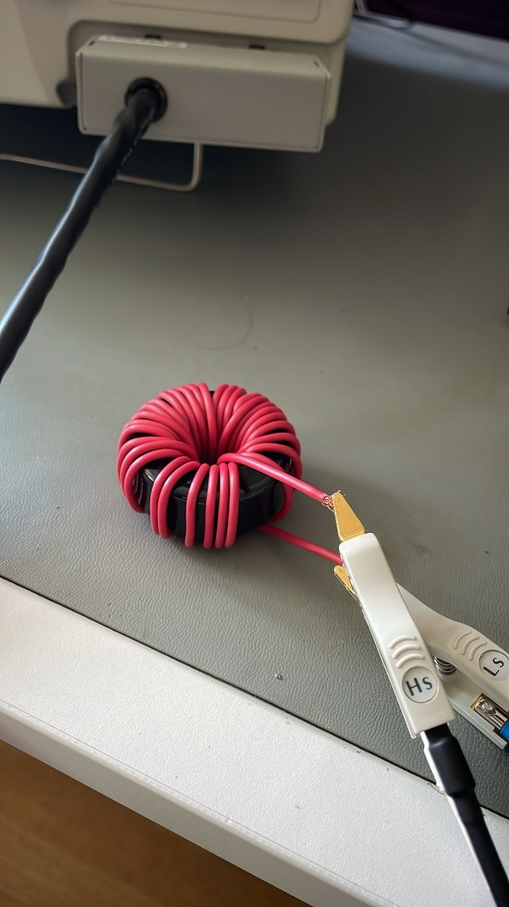

Figure 3. Output inductor design and test setup

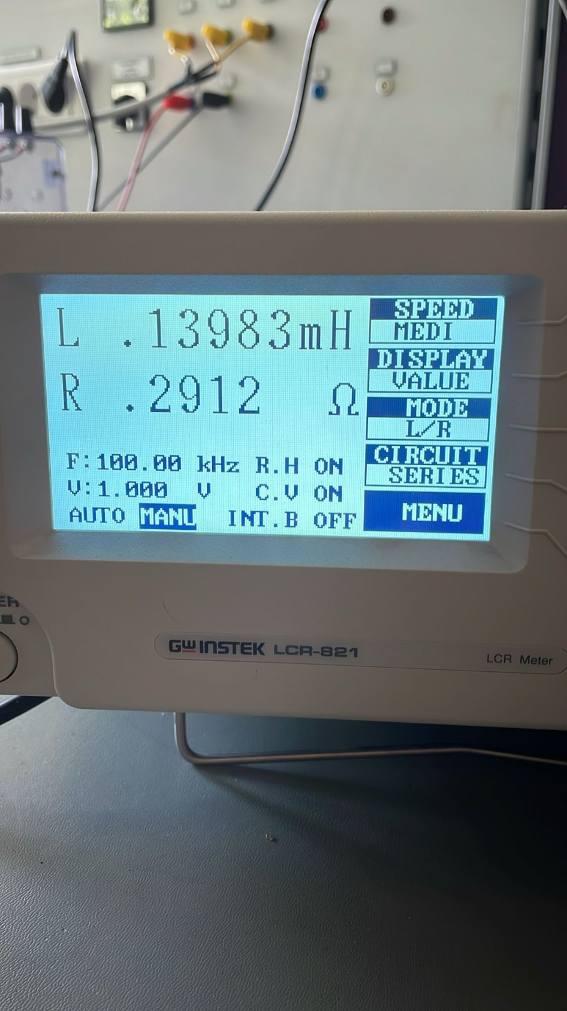

Figure 4. RL Test for Output Inductance

## Magnetizing and Leakage Inductance Tests

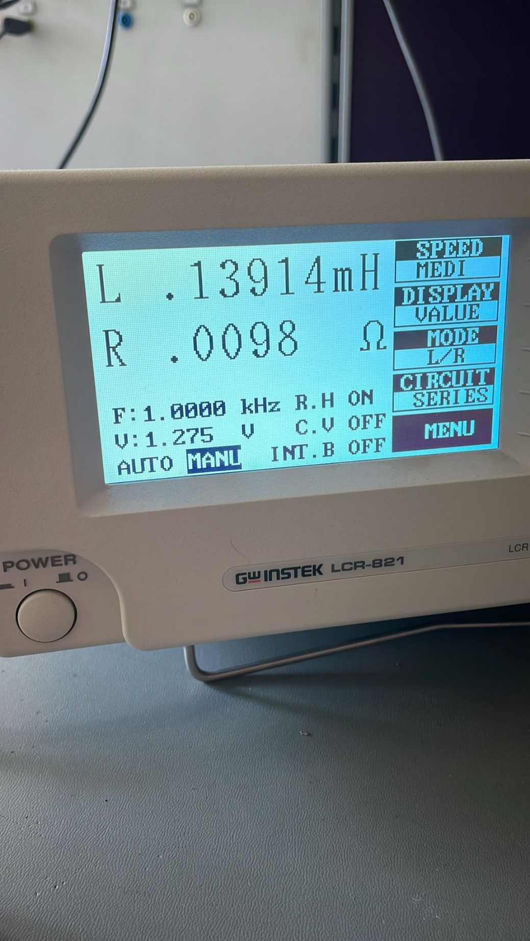

Figure 5. From Primary side, Secondary open

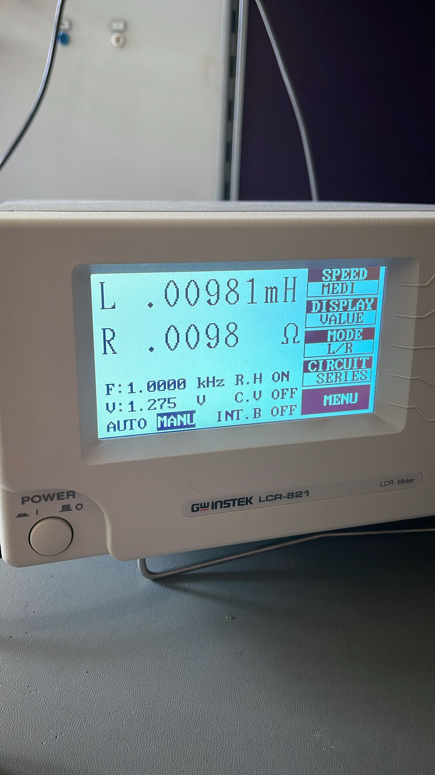

Figure 6. From Primary side, Secondary shorted

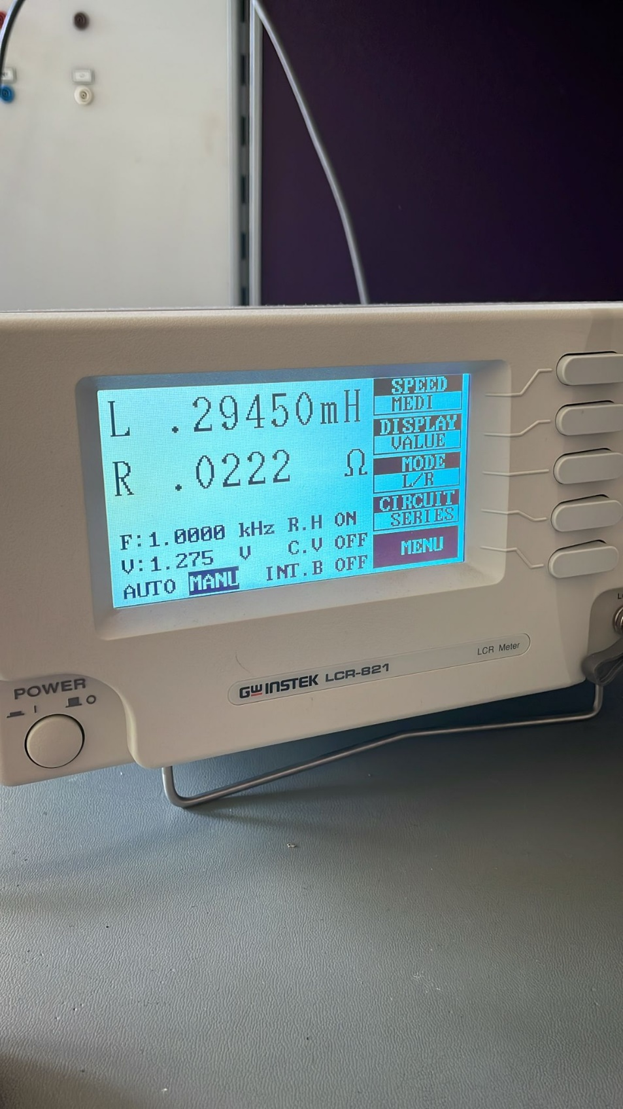

Figure 7. From Primary side, Secondary open

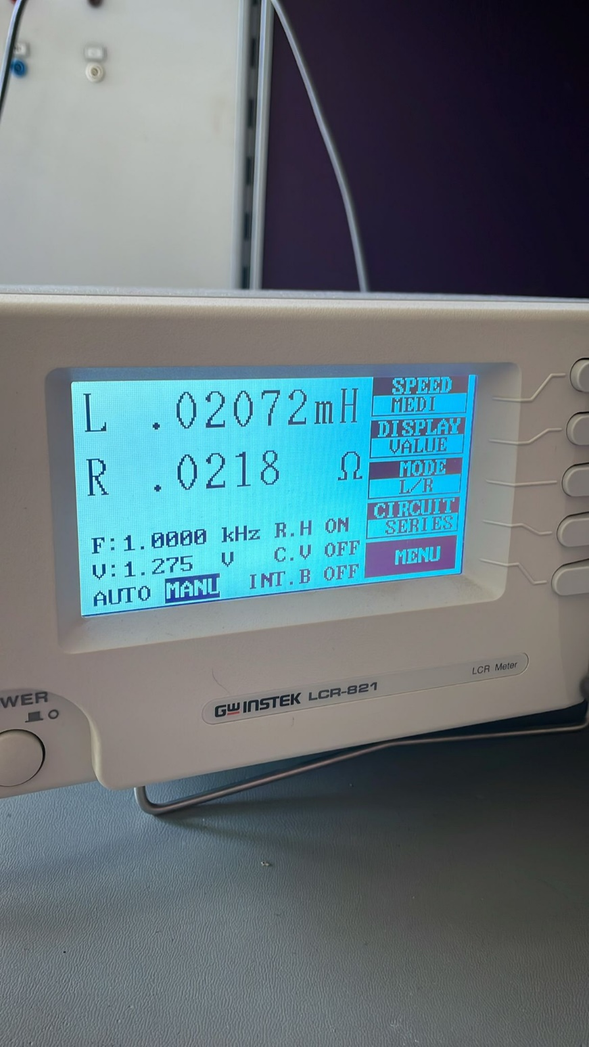

Figure 8. From secondary, primary shorted

From these tests we concluded that:

$L_{l1}=9.8$**µH**

$L_{M}=130$**µH**

$L_{l2}=20.7$**µH**

# Component Selection

## MOSFET

metin, yazı tipi, çizgi, diyagram içeren bir resim

Açıklama otomatik olarak oluşturuldu

Consideration of these equations for MOSFET, we decided to use IRF540N. Its mean and peak values are below rated for this MOSFET.

metin, ekran görüntüsü, paralel, diyagram içeren bir resim

Açıklama otomatik olarak oluşturuldu

Figure 26. IRF540 MOSFET

### GATE DRİVER

metin, ekran görüntüsü, yazı tipi, doküman, belge içeren bir resim

Açıklama otomatik olarak oluşturuldu

Figure 27. LT8311 Driver

LT8311 driver for forward converter can be used to drive our mosfets. It has built-in optocoupler for isolation purposes to get information for feedback control.

## DİODE

Selection of 10A ratings will be enough for this application.

**MBR2010CT** diodes can be selected for this application.

metin, ekran görüntüsü, yazı tipi, diyagram içeren bir resim

Açıklama otomatik olarak oluşturuldu

Figure 28. MBR20100CT Diode

## OPTOCOUPLER

metin, ekran görüntüsü, yazı tipi, doküman, belge içeren bir resim

Açıklama otomatik olarak oluşturuldu

Figure 29. LT8311 Driver

This LT8311 MOSFET Driver have an Opto-coupler inside that we can use to control feedback for MOSFET’s.

# Closed Loop Controller

For the controller design, digital controller will be used. However, if reasonable analog controller is found, it can be used, but at the first stage, digital controller will be used. For the microcontroller, Arduino Nano will be used. It can supply PWM signal. In our topology, we should control two switches. They should work simultaneous, so they are at on and off periods in same time. It will be very big challenge for this topology.

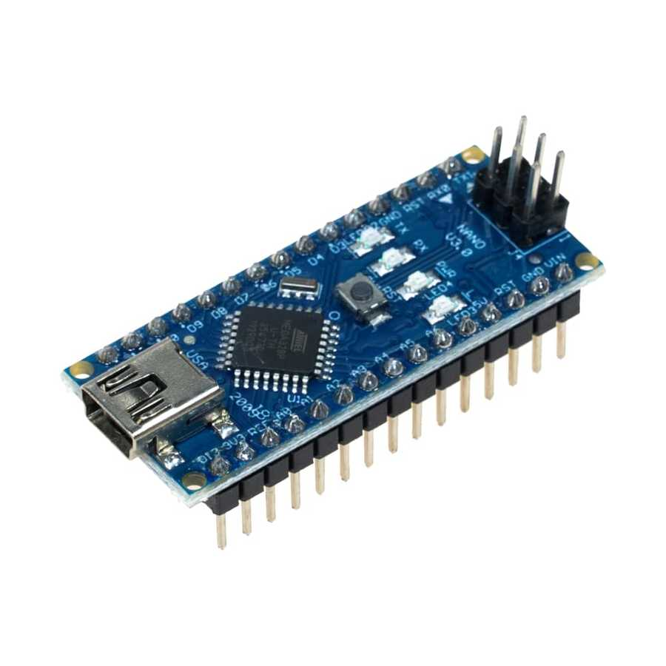

Figure 9. Arduino Nano

As we discussed, duty cycle should be limited to 0.5. It is another challenge for the controlling MOSFET’s. Duty cycle algorithm will be determined when the experiments are done. First decision for control algorithm, we should control output voltage and current. For this purpose, we should take feedback from the load. For this purpose, voltage sensing units will be used. According to analog data at Arduino pins, they will be transformed to digital signal, and it will range between the bit number. From this data collection, duty cycle will be controlled. For the observing current at the load, stone resistor will be used with high power rating. On this resistor, voltage value will be measured. Then dividing this value with resistor value give us a current rating at the load.

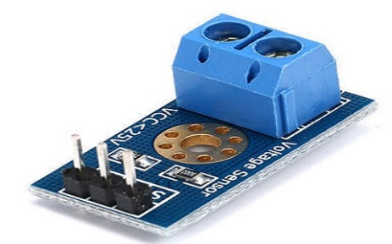

Figure 10. Voltage Sensing Unit

Our control algorithm can be seen in block diagram 1.

metin, diyagram, çizgi, ekran görüntüsü içeren bir resim

Açıklama otomatik olarak oluşturuldu

Block Diagram 1. Control Loop for Duty Cycle

So, with this specification, voltage and current sensing should be very sensitive and error margin will be very low. It will be challenge for us and we should consider this situation.

After the completing the project, digital screen which shows voltage rating of the battery and current value of the load will be designed.

## Controller Tuning

Write each pin calculations

# Simulations

Simulation is done with LTSpice. Two-switch forward converter topology is implemented at the simulation. Simulation is done with maximum and minimum input voltages. Spikes or over-voltages are observed, and they will be considered for a component selection.

metin, ekran görüntüsü, çizgi, yazı tipi içeren bir resim

Açıklama otomatik olarak oluşturuldu

Figure 11. Forward Converter Schematic with LTSpice

MBR20100CT diode and BSB014N04LX3 MOSFET is selected for a simulation. Required inductor is calculated as 100 µH in the theoretical calculations. Designed inductor’s inductance is around 139.83 µH and series resistance is calculated as 0.8 ohm. Resistance value is quite high, and it will cause high loss at the inductor. So, used wire and core can be changed. However, simulations done with these values.

Turns ratio is determined 1.5 and this value is implemented to primary and secondary winding inductance. Transformer design’s experiments and measurements give us some leakage inductance and serial resistance at primary and secondary side. They are measured as 9.81 µH and 9.8 mohm at the primary side. Then at the secondary side, leakage inductance is around 20 µH and resistance is around 21.8 mohm. These values are acceptable due to some theoretical results and turns ratio. Magnetizing inductance value at the primary side is around 130 µH and at the secondary side is around 274 µH. These values are acceptable too. So, with these values, practical system is implemented, and simulation results are observed.

**Case 1: Minimum Input Voltage**

Simulations done with 20 V input voltage. Leakage inductance, magnetizing inductance and resistance is added. According to these simulations, waveforms on diodes, mosfets, required duty cycle and load characteristics are observed.

**MOSFET WAVEFORMS**

çizgi, öykü gelişim çizgisi; kumpas; grafiğini çıkarma, diyagram, ekran görüntüsü içeren bir resim

Açıklama otomatik olarak oluşturuldu

Figure 12. M-2 Voltage and Current Waveform

çizgi, öykü gelişim çizgisi; kumpas; grafiğini çıkarma, diyagram, sayı, numara içeren bir resim

Açıklama otomatik olarak oluşturuldu

Figure 13. M-1 Voltage and Current Waveform

According to simulations, voltage and current characteristics on the MOSFET’s are very similar, peak current goes 9.5 A and peak voltage on the VDS is around 21 V. VRMS on the VDS is around 14.302 V and IRMS is around 6.072 A. According to these information, MOSFET selection will be done.

**DIODES WAVEFORMS AT PRIMARY SIDE**

çizgi, öykü gelişim çizgisi; kumpas; grafiğini çıkarma, paralel içeren bir resim

Açıklama otomatik olarak oluşturuldu

Figure 14. Voltage Waveforms of the Diodes at Primary Side

çizgi, öykü gelişim çizgisi; kumpas; grafiğini çıkarma, diyagram, paralel içeren bir resim

Açıklama otomatik olarak oluşturuldu

Figure 15. Current Waveforms of the Diodes at Primary Side

From the simulations, voltage and current characteristics of diodes at primary side is nearly same. According to waveforms, maximum current is around 9.5 A and maximum voltage when reverse biased is around 20 V. At the simulations, forward bias voltage is can be seen. So, from these results, diodes at the primary side will be selected.

**DIODES WAVEFORMS AT SECONDARY SIDE**

çizgi, ekran görüntüsü, öykü gelişim çizgisi; kumpas; grafiğini çıkarma, yazı tipi içeren bir resim

Açıklama otomatik olarak oluşturuldu

Figure 16. Current Waveforms of the Diodes at Secondary Side

çizgi, öykü gelişim çizgisi; kumpas; grafiğini çıkarma, yazı tipi, diyagram içeren bir resim

Açıklama otomatik olarak oluşturuldu

Figure 17. Voltage Waveforms of the Diodes at Secondary Side

From the voltage and current waveforms, characteristics of the diodes are observed. Very big oscillation is observed at the voltage waveforms. Current waveforms are stable and maximum current rating is around 5.3 A. When voltage waveforms are examined, spike reverse biased voltages can goes up to 80 V. Normally, it is around 30 V without oscillation. So, from these observations, diode will be selected.

**INDUCTOR WAVEFORM AT THE SECONDARY SIDE**

çizgi, öykü gelişim çizgisi; kumpas; grafiğini çıkarma, diyagram, yazı tipi içeren bir resim

Açıklama otomatik olarak oluşturuldu

Figure 18. Voltage and Current Waveform of the Inductor

From the inductor waveform, voltage on the inductor has very big oscillation and current varies between 4.80-5.30 A. So, system operates in continuous conduction mode. Ripple is around. 0.5 / 5 = 10%.

**LOAD CHARACTERISTICS**

For observing 5 A at load, load is selected as 2.4 ohm.

çizgi, öykü gelişim çizgisi; kumpas; grafiğini çıkarma, sayı, numara, yazı tipi içeren bir resim

Açıklama otomatik olarak oluşturulduFigure 19. Voltage and Current Waveforms at Load

From the characteristics of the load, required output voltage and current is provided. Ripple at outside is calculated as 0.36 / 5 = 7.2%. It is quite high according to system specification, so output capacitor will be selected as 1 µF in order to 470 nF. This system is operating with 0.5 duty cycle as expected. However, with ideal system, it should be operated with 0.4 duty cycle. However, with leakage inductances and resistances, this value increase to 0.5. So, for the safety of operation and operating without saturation of the core, transformer design may be redesigned.

**Case 2: 40 V Input Voltage Case**

Simulations done with 20 V input voltage. Leakage inductance, magnetizing inductance and resistance is added. According to these simulations, waveforms on diodes, mosfets, required duty cycle and load characteristics are observed.

**Diodes at Primary Side**

çizgi, öykü gelişim çizgisi; kumpas; grafiğini çıkarma, metin, sayı, numara içeren bir resim

Açıklama otomatik olarak oluşturuldu

Figure 20. Voltage Waveforms of the Diodes at Primary Side

From the simulations, voltage, and current characteristics of diodes at primary side is nearly same. According to waveforms, maximum current is around 8.5 A and maximum voltage when reverse biased is around 40 V. At the simulations, forward bias voltage is can be seen. So, from these results, diodes at the primary side will be selected. Also, oscillations are observed. IRMS value is around 245 mA and VRMS is around 24.58 V.

**MOSFET WAVEFORMS**

çizgi, metin, öykü gelişim çizgisi; kumpas; grafiğini çıkarma, yazı tipi içeren bir resim

Açıklama otomatik olarak oluşturuldu

Figure 21. Voltage and Current Waveforms of the MOSFET’s at Primary Side

According to simulations, voltage and current characteristics on the MOSFET’s are very similar, peak current goes 8.5 A and peak voltage on the VDS is around 40 V. VRMS on the VDS is around 24.302 V and IRMS is around 3.56 A. According to these information, MOSFET selection will be done. Moreover, oscillation is observed when switch is closed. However, this oscillation is not higher. Because of used topology, RCD snubber circuit is not required.

**Inductance Waveforms of TRANSFORMER**

çizgi, öykü gelişim çizgisi; kumpas; grafiğini çıkarma, ekran görüntüsü, diyagram içeren bir resim

Açıklama otomatik olarak oluşturuldu

Figure 22. Current Waveforms of Inductance at Transformer

I(L1) and I(L4) are current waveforms of winding and magnetizing inductance. As expected, current on magnetizing inductance goes 0 when switches are off and charging when switches are on. It is a good operation mode for protection from saturating of core.

**DIODES WAVEFORMS AT SECONDARY SIDE**

çizgi, öykü gelişim çizgisi; kumpas; grafiğini çıkarma, yazı tipi, ekran görüntüsü içeren bir resim

Açıklama otomatik olarak oluşturuldu

Figure 23. Current and Voltage Waveforms of Diodes at Secondary Side

From the voltage and current waveforms, characteristics of the diodes are observed. Very big oscillation is observed at the voltage waveforms. Current waveforms are more stable, but it has oscillation at off period and maximum current rating is around 5.3 A. When voltage waveforms are examined, spike reverse biased voltages can goes up to 150 V. Normally, it is around 30 V without oscillation. So, from these observations, diode will be selected.

**INDUCTOR WAVEFORMS AT SCONDARY SIDE**

metin, çizgi, öykü gelişim çizgisi; kumpas; grafiğini çıkarma, ekran görüntüsü içeren bir resim

Açıklama otomatik olarak oluşturuldu

Figure 24. Voltage and Current Waveforms of Inductor at Secondary Side

From the waveform characteristics of the inductor, current varies between 4.69 A and 5.28 A. Voltage has very big spikes at inductor. However, these spikes occur at very small time intervals. Spikes can go up to 130 V. It is quite high value. Filter for the output side can be considered.

**LOAD CHARACTERISTIC**

çizgi, ekran görüntüsü, sayı, numara, paralel içeren bir resim

Açıklama otomatik olarak oluşturuldu

Figure 25. Current Waveform of Load

From the waveform of the load, current varies between 4.75 A and 5.23 A. Average value is around 5 A. However, ripple at load is around 0.5 / 5 = 10%. It is quite high. Again output capacitor will be considered again and 1 µF capacitor will be used in order to 470 nF capacitor.

# Loss Calculations

# Implementation Process

## Switching to Forward Converter Topology

## RC Snubber on Diodes

# Cost Anaylsis

# Bonuses

# Conclusion

In conclusion, for the specified project aiming to develop an efficient and open-source isolated DC-DC converter with a focus on achieving stable output voltage and high efficiency, the choice of topology is crucial. Given the project's requirements and objectives, the forward converter topology emerges as a suitable option due to its inherent advantages in efficiency, regulation, and suitability for higher power levels.

**Topology Selection: Two Switch Forward Converter**

The two switch forward converter topology offers several key advantages for this project:

Regulation: Forward converters typically provide better output voltage regulation across varying load conditions compared to alternative topologies like flyback converters.

Output Ripple: With careful design and control, forward converters can exhibit lower output voltage ripple, meeting the project's requirement of a peak-to-peak ripple of 3%.

**Future Work and Development:**

Optimization for Efficiency: Implement further optimization techniques such as soft-switching methods (e.g., resonant converters) to enhance efficiency and reduce switching losses.

Compact Design: Explore design strategies to achieve a more compact layout, potentially integrating components and optimizing the transformer and inductor designs for reduced size and weight. We will try to implement our design on PCB.

High Power Density: Investigate advanced packaging techniques and material selection to increase power density without compromising thermal management and reliability.

Closed-Loop Control: Develop and implement robust closed-loop control algorithms to ensure stable and accurate regulation under varying input voltage and load conditions. We will focus on the problem of going into saturation from based on the suggestions from the past. We will adress this sooner and try to solve it.

# Achievements

# Appendix-I : TEST DATA

# References

1. <https://www.mouser.com/pdfdocs/2-10.pdf>